**Aero Series**

Amco Veba has many years of experience in special applications requested in different markets present all over the world such as agriculture, defence, tire handling, car recovery, aerial operations.

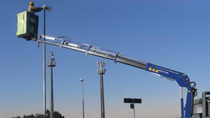

**805T-905T AERO**

Max. Lifting capacity (kg)

1605

Lifting Moment Class (tm)

3

Max. Extension reach (m)

7.5

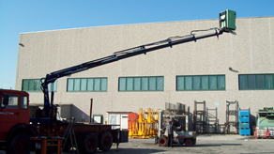

**807NT-907NT AERO**

Max. Lifting capacity (kg)

2350

Lifting Moment Class (tm)

5

Max. Extension reach (m)

10.05